~1. Introduction WAN Technologies Theory:-
- Create a comparison table listing at least 3 key differences between WAN and LAN, and give one real-world example of each from apps or services you use daily (for example, IRCTC, Instagram, or Zomato).
Feature | LAN (Local Area Network) | WAN (Wide Area Network)
1. Coverage Area | Covers a small area such as a room, building, or campus. | Covers large areas such as cities, countries, or the whole world.
2. Speed | Usually provides higher speed because devices are nearby. | Usually has comparatively higher latency and depends on long-distance connections.
3. Ownership | Usually owned and managed by an organization or individual. | Usually has comparatively higher latency and depends on long-distance connections.
4. Example | College Wi-Fi network connecting computers in a computer lab. | Instagram uses WAN/Internet connections to communicate with servers and users worldwide.

Real-world examples:
- LAN: A college computer lab where PCs and printers are connected through a local switch.
- WAN: IRCTC — your device connects through the Internet to IRCTC's servers, which may be located far away.

- Draw a simple network diagram using any drawing tool (or on paper and upload a photo) that shows how a user in Ahmedabad could connect to a Flipkart data center in Bangalore using a WAN, labeling the LAN and WAN segments clearly.
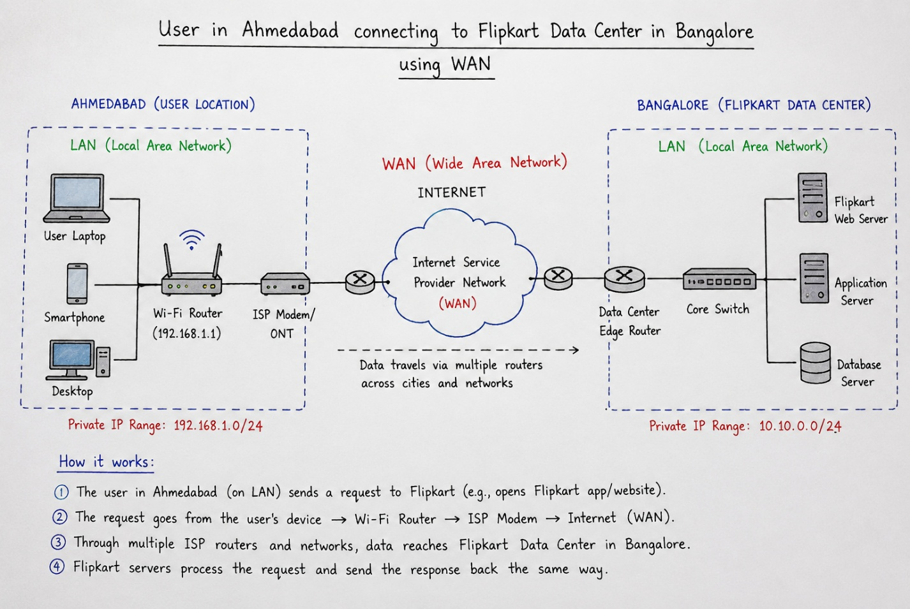
Scenario:
A user in Ahmedabad wants to access the Flipkart website/app, whose data center is located in Bangalore.
- The user's laptop connects to the Ahmedabad LAN through a Wi-Fi router.
- The request leaves the LAN and travels through the Internet/WAN using multiple routers and ISP networks.
- The request reaches the Flipkart data center in Bangalore, which has its own LAN connecting web and application servers.
- The Flipkart server processes the request and sends the response back to the user through the WAN.
In short:
Ahmedabad User → Ahmedabad LAN → ISP → WAN/Internet → Bangalore → Flipkart LAN → Flipkart Servers

- Research and write a short summary (5-7 lines) explaining what MPLS is and how it improves data routing compared to traditional IP routing.
MPLS – Short Summary:
- MPLS (Multiprotocol Label Switching) is a networking technology used to transfer data efficiently across large networks.
- Instead of checking the full IP address at every router, MPLS uses short labels to forward packets.
- These labels help routers quickly identify the path a packet should follow.
- MPLS can provide more predictable performance and better traffic management than traditional IP routing.
- It supports Quality of Service (QoS), allowing important traffic such as voice or video to receive suitable priority.
- MPLS is commonly used by ISPs and large organizations to connect offices and data centers over WANs.
- Therefore, MPLS can make large-scale network communication more efficient, manageable, and reliable.

- Observe the pre-configured MPLS network in the provided Packet Tracer or GNS3 file, and note down two routing behaviors that are different from standard IP routing.<br><br><em><strong>Hint:</strong> Look for how labels are used and how packets move between routers.</em>
MPLS Routing Behaviors Different from Standard IP Routing:
- Label-based forwarding: MPLS routers forward packets using short labels instead of checking the complete destination IP address at every hop.
- Label Switched Path (LSP): Packets can follow a predefined LSP through the MPLS network instead of each router independently selecting the next hop.
- Label swapping: At each MPLS router, the incoming label can be replaced with a new label before forwarding the packet to the next router.
- Label Push: When a packet enters an MPLS network, an MPLS router can add a label to the packet so that subsequent routers know how to forward it.
- Label Pop: Near the destination, a router can remove the MPLS label, allowing the packet to continue using normal IP forwarding.
- Traffic Engineering: MPLS can control the path used by traffic, helping avoid congested links and making better use of available network capacity.
- QoS support: MPLS can classify different types of traffic and provide different levels of priority, which is useful for applications such as voice and video.
- Fast forwarding: Once the label-switched path is established, intermediate routers can make forwarding decisions using the label rather than performing a full IP routing lookup.
Key difference:
Traditional IP:
Packet → Check Destination IP → Routing Table → Next Router
MPLS:
Packet → Read Label → Swap Label → Next Router

- List three specific benefits MPLS offers over traditional routing for companies running high-traffic apps like YouTube or BookMyShow, and briefly explain how each benefit helps in real-world scenarios.

Three Benefits of MPLS for High-Traffic Companies:
Benefit: | Explanation | Real-World Scenario
1. Traffic Engineering: | MPLS allows companies to control the path taken by network traffic and avoid congested links. | YouTube: Video traffic can be directed through less-congested paths, helping reduce buffering during peak hours.
2. Quality of Service (QoS): | MPLS can prioritize important traffic, such as voice, video, or business-critical data. | BookMyShow: Payment and ticket-booking traffic can receive higher priority so transactions remain responsive during popular movie releases.
3. Reliable and Predictable Performance: | MPLS can provide controlled paths and fast rerouting when a network link fails. | BookMyShow: If one network link becomes unavailable during a major ticket sale, traffic can be redirected through another available path, reducing disruption.

In short: MPLS helps high-traffic companies achieve better traffic control, improved performance for important applications, and more reliable connectivity.

THE END…….

